**Project Proposal – Surf Explorer Visualization**

**Background and Motivation**. Discuss your motivations and reasons for choosing this project, especially any background or research interests that may have influenced your decision.

When planning a surf trip, one needs to take into account several factors such as seasonal variation in tides, since surf spots tend to “go off” (surf slang for has good waves) only during certain periods of the year.

Depending on her surfing skill level, a surfer may also have a preference for a certain type of wave - whether fast and hollow “tubes” or “crumbly” soft waves – as well as wave height.

Surf stance also affects wave direction preferences, as it is much easier to surf front side, that is, facing the wave, than backside. This is why most “goofy” surfers (that surf with their left foot forward) will have a preference for left-hand breaks.

Novice surfers may also prefer to surf on beach-breaks rather than on reef-breaks since there is less chance of suffering scrapes and cuts on a sandy bottom.

This visualization aims to help surfers plan their next surf trip by allowing surfers to find surf spots with their preferred characteristics that will be “going off” during their travel window.

**Project Objectives**. Provide the primary questions you are trying to answer with your visualization. What would you like to learn and accomplish? List the benefits.

Our visualization allows a surfer to readily identify which surfspots she should consider on her next surf trip according to travel window and desired characteristics.

**Data**. From where and how are you collecting your data? If appropriate, provide a link to your data sources.

There is an online surf atlas that at <http://www.wannasurf.com/> that has information for surf spots all over the world.

Wave-forecasts for these surf spots are available from http://magicseaweed.com/.

**Data Processing**. Do you expect to do substantial data cleanup? What quantities do you plan to derive from your data? How will data processing be implemented?

We will scrape the surf atlas in order to grab the surf spot information to be able to display it on a map and provide a search function over surf spot characteristics.

**Visualization**. How will you display your data? Provide some general ideas that you have for the visualization design. Include sketches of your design.

A “Surf Explorer” dash board that contains several dropdown menus for surfers to choose their month of travel and desired surf spot characteristics, including: wave height, direction, type of wave, type of bottom, among others. These menus will allow to filter surf spots displayed on a world map.

Selecting a surf spot on the map will bring up more detailed information on that surf spot such as spot description and graphs of wave height, air and water temperatures across time.

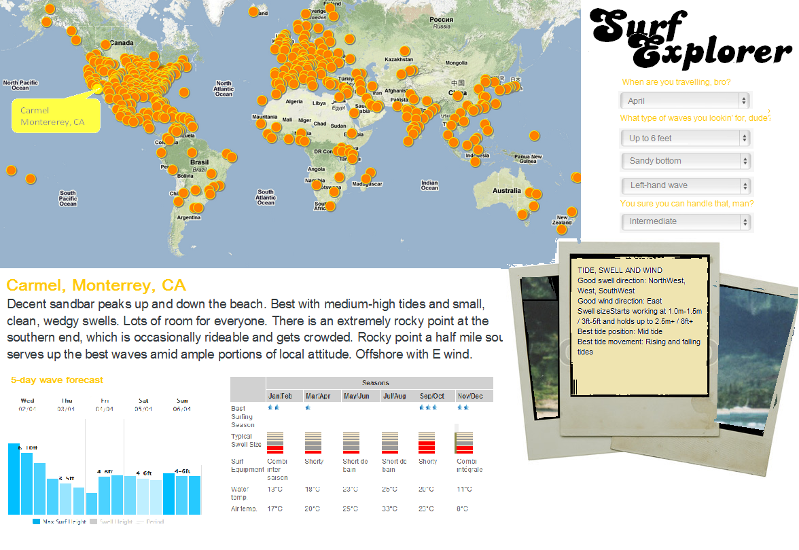

**Must-Have Features**. These are features without which you would consider your project to be a failure.

Dropdown menu of surf characteristics that allows to filter surf spots on a map.

Selecting a surf spot displays additional information such as description, graphs of wave characteristics across time.

**Optional Features**. Those features which you consider would be nice to have, but not critical.

An additional feature would be to display the 5-day wave forecast for the selected surf spot.

**Project Schedule**. Make sure that you plan your work so that you can avoid a big rush right before the final project deadline, and delegate different modules and responsibilities among your team members. Write this in terms of weekly deadlines.

Apr 3rd: Develop API and download data

Apr 10th: Finalize data exploration

Apr 17th: Finalize design template

Apr 24th: First draft

May 1st: Final deadline